**Data structures and Algorithms**

**NAME: Akshita Pattnaik**

**SUPERSET ID: 6360271**

**Exercise 2: E-commerce Platform Search Function**

**Scenario:**

You are working on the search functionality of an e-commerce platform. The search needs to be optimized for fast performance.

**Steps:**

1. **Understand Asymptotic Notation:**
   * Explain Big O notation and how it helps in analyzing algorithms.
   * Describe the best, average, and worst-case scenarios for search operations.
2. **Setup:**
   * Create a class **Product** with attributes for searching, such as **productId, productName**, and **category**.
3. **Implementation:**
   * Implement linear search and binary search algorithms.
   * Store products in an array for linear search and a sorted array for binary search.
4. **Analysis:**
   * Compare the time complexity of linear and binary search algorithms.
   * Discuss which algorithm is more suitable for your platform and why.

**ANSWER:**

1.Big O notation describes the upper bound of an algorithm's runtime or space requirements in terms of input size n. It helps developers understand how algorithms scale.

| **Case** | **Linear Search** | **Binary Search** |
| --- | --- | --- |
| **Best** | O(1) (first element) | O(1) (middle match) |
| **Average** | O(n) | O(log n) |
| **Worst** | O(n) | O(log n) |

**CODE:**

**Program.cs:**

using System;

namespace ECommerceSearch

{

class Program

{

static void Main(string[] args)

{

// Sample products

Product[] products = new Product[]

{

new Product(101, "Shoes", "Footwear"),

new Product(102, "T-shirt", "Clothing"),

new Product(103, "Laptop", "Electronics"),

new Product(104, "Phone", "Electronics"),

new Product(105, "Book", "Stationery")

};

// Sort products by ProductName for binary search

Array.Sort(products, (p1, p2) => string.Compare(p1.ProductName, p2.ProductName, StringComparison.OrdinalIgnoreCase));

Console.WriteLine("🛍️ Welcome to the E-Commerce Product Search System!");

bool running = true;

while (running)

{

Console.WriteLine("\nPlease choose an option:");

Console.WriteLine("1. Linear Search");

Console.WriteLine("2. Binary Search");

Console.WriteLine("3. Exit");

Console.Write("Enter your choice: ");

string input = Console.ReadLine();

switch (input)

{

case "1":

Console.Write("Enter product name to search (Linear): ");

string linearSearchTerm = Console.ReadLine();

int linearIndex = LinearSearch(products, linearSearchTerm);

if (linearIndex != -1)

Console.WriteLine($"✅ Product found: {products[linearIndex]}");

else

Console.WriteLine("❌ Product not found using linear search.");

break;

case "2":

Console.Write("Enter product name to search (Binary): ");

string binarySearchTerm = Console.ReadLine();

int binaryIndex = BinarySearch(products, binarySearchTerm);

if (binaryIndex != -1)

Console.WriteLine($"✅ Product found: {products[binaryIndex]}");

else

Console.WriteLine("❌ Product not found using binary search.");

break;

case "3":

Console.WriteLine("👋 Exiting the search system. Have a nice day!");

running = false;

break;

default:

Console.WriteLine("⚠️ Invalid choice! Please select 1, 2 or 3.");

break;

}

}

}

public static int LinearSearch(Product[] products, string targetName)

{

for (int i = 0; i < products.Length; i++)

{

if (products[i].ProductName.Equals(targetName, StringComparison.OrdinalIgnoreCase))

return i;

}

return -1;

}

public static int BinarySearch(Product[] products, string targetName)

{

int left = 0;

int right = products.Length - 1;

while (left <= right)

{

int mid = left + (right - left) / 2;

int comparison = string.Compare(products[mid].ProductName, targetName, StringComparison.OrdinalIgnoreCase);

if (comparison == 0)

return mid;

else if (comparison < 0)

left = mid + 1;

else

right = mid - 1;

}

return -1;

}

}

public class Product

{

public int ProductId { get; }

public string ProductName { get; }

public string Category { get; }

public Product(int productId, string productName, string category)

{

ProductId = productId;

ProductName = productName;

Category = category;

}

public override string ToString()

{

return $"ID: {ProductId}, Name: {ProductName}, Category: {Category}";

}

}

}

**OUTPUT:**

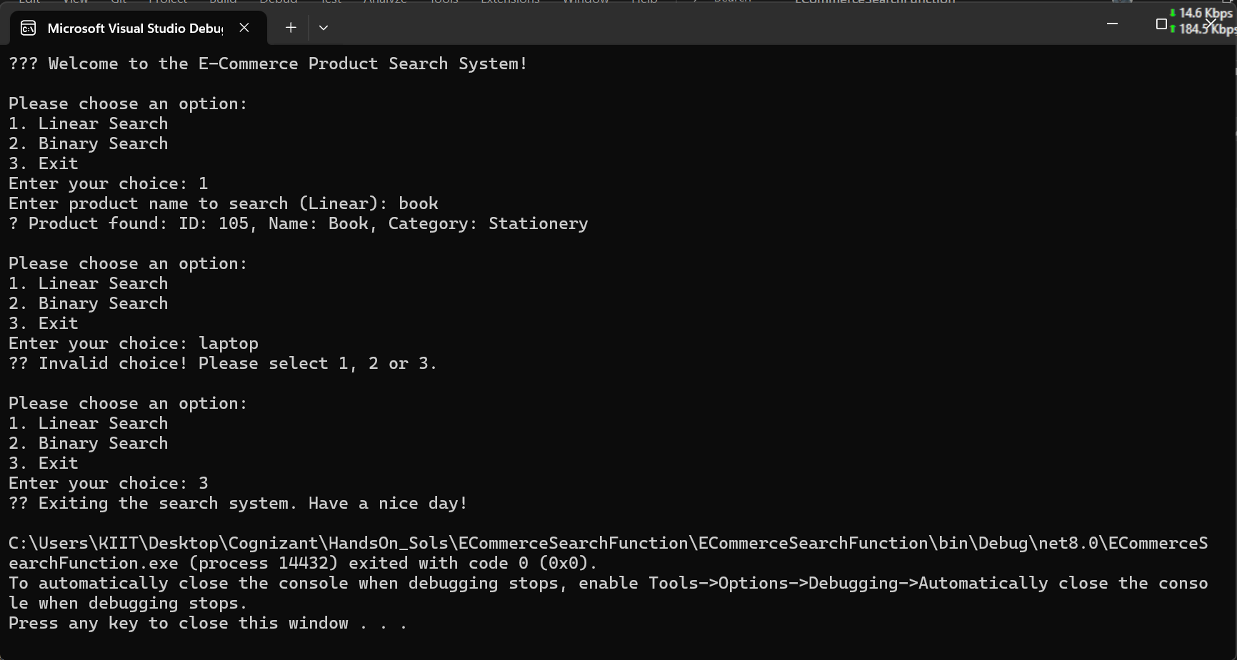

4.

| **Algorithm** | **Time Complexity** | **When to Use** |
| --- | --- | --- |
| Linear Search | **O(n)** | Small datasets or unsorted data |
| Binary Search | **O(log n)** | Large datasets that are sorted |
|  |  |  |

For an **e-commerce platform**, where performance and scalability are critical:

* Prefer Binary Search with sorted data or better, use indexes or hashing or even databases with indexing.
* For small datasets or rare use-cases where data isn't sorted, linear search is acceptable.

**Exercise 7: Financial Forecasting**

**Scenario:**

You are developing a financial forecasting tool that predicts future values based on past data.

**Steps:**

1. **Understand Recursive Algorithms:**
   * Explain the concept of recursion and how it can simplify certain problems.
2. **Setup:**
   * Create a method to calculate the future value using a recursive approach.
3. **Implementation:**
   * Implement a recursive algorithm to predict future values based on past growth rates.
4. **Analysis:**
   * Discuss the time complexity of your recursive algorithm.
   * Explain how to optimize the recursive solution to avoid excessive computation.

**ANSWERS:**

1. Recursion is a method where a function calls itself to solve smaller subproblems.

Ideal for problems that can be broken down into similar subproblems (e.g., factorial, Fibonacci, forecasting based on past values).

**CODE:**

**Program.cs:**

using System;

namespace FinancialForecasting

{

internal class Program

{

static void Main(string[] args)

{

Console.WriteLine("Enter current value (e.g., 1000):");

double currentValue = Convert.ToDouble(Console.ReadLine());

Console.WriteLine("Enter annual growth rate (as percentage, e.g., 10):");

double growthRate = Convert.ToDouble(Console.ReadLine()) / 100;

Console.WriteLine("Enter number of years to forecast:");

int years = Convert.ToInt32(Console.ReadLine());

double futureValue = PredictFutureValue(currentValue, growthRate, years);

Console.WriteLine($"\nPredicted value after {years} years: {futureValue:F2}");

}

static double PredictFutureValue(double currentValue, double growthRate, int years)

{

if (years == 0)

return currentValue;

return PredictFutureValue(currentValue * (1 + growthRate), growthRate, years - 1);

}

}

}

**OUTPUT:**

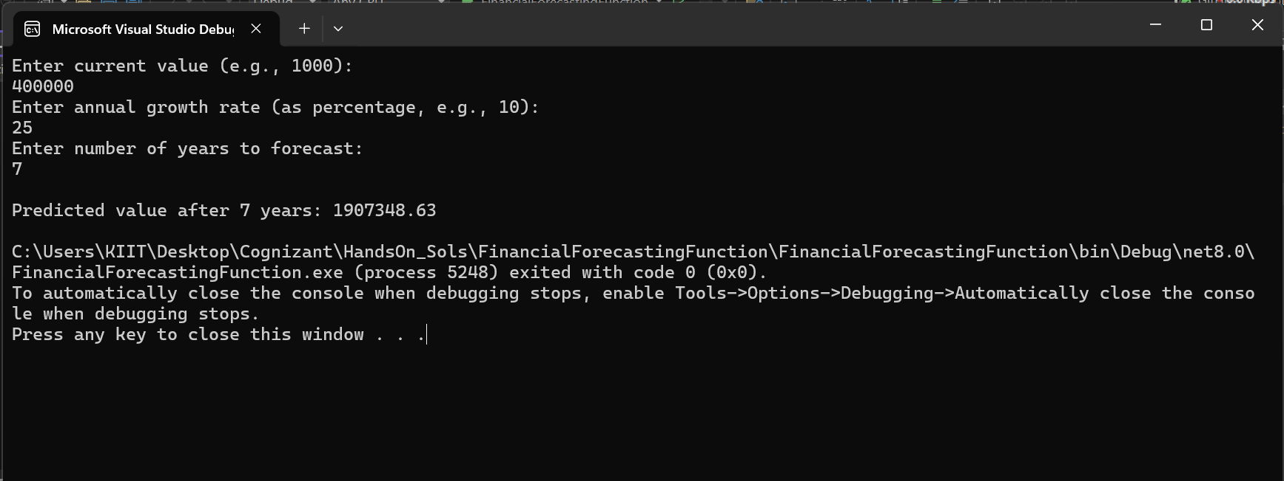

4.

| **Version** | **Time Complexity** | **Space Complexity** |
| --- | --- | --- |
| Basic Recursion | O(n) | O(n) (call stack) |
| Memoized Recursion | O(n) | O(n) (memo array) |

* Recursive calls add up fast. Without optimization, values may be recomputed multiple times.
* Memoization stores previously computed values, reducing redundant calculations.